**Problem 01**

Write a C++ program with the following specifications:

1. Use two-dimensional array with size 7 columns and 5 rows.
2. Seat numbers are populated during run-time.
3. User is asked to input a seat number.
4. Seat number chosen is replaced by 0.
5. Program displays a remark “Seat successfully reserved” when reservation is done.
6. User is not allowed to reserve a previously reserved seat. Display “Seat is taken” remarks.
7. User is not allowed to enter an invalid seat number. Display an error message.
8. Program continuously loops.

Sample Output:

1 2 3 4 5 6 7

8 9 10 11 12 13 14

15 16 17 18 19 20 21

22 23 24 25 26 27 28

29 30 31 32 33 34 35

Enter seat number to reserve : 11

1 2 3 4 5 6 7

8 9 10 0 12 13 14

15 16 17 18 19 20 21

22 23 24 25 26 27 28

29 30 31 32 33 34 35

Enter seat number to reserve :

**Solution and Testing 01**

Video of the source code and compilation process is found in:

<https://www.youtube.com/watch?v=uN-qNf7HAcE>

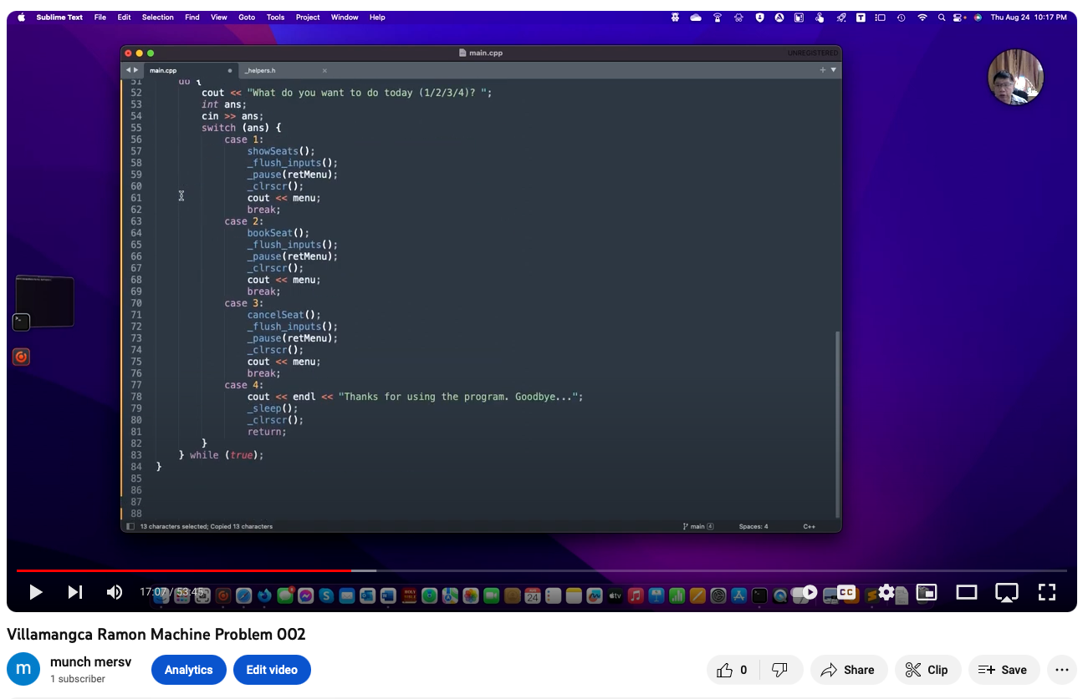

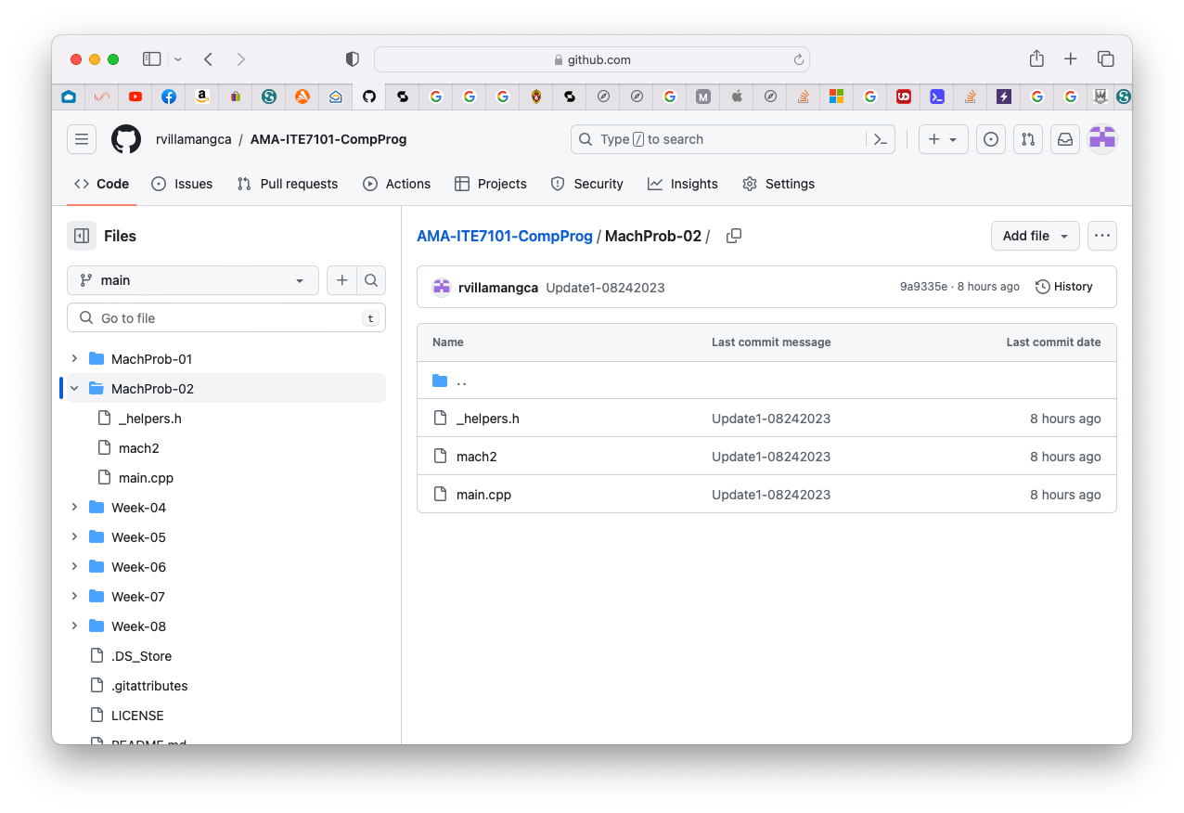Source code can be found on my GitHub page: <https://github.com/rvillamangca/>.

Below is the screenshot of solution program as well as testing in the terminal.

